Firstly, please send me your camera system’s version information, as below picture shown,
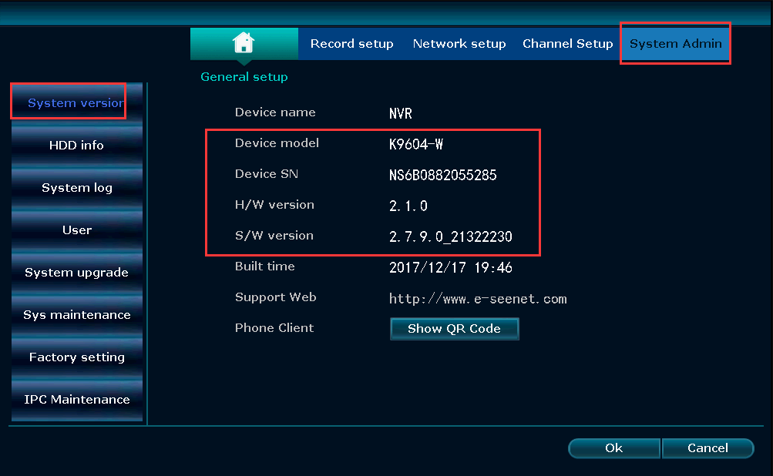

Or according to the link below, you can upgrade the camera system by yourself. Please upgrade the camera system to the latest version.
https://anran-cctv.com/faq-items/q-how-to-upgrade-the-wireless-camera-system/
Setting email alarm:
The Cloud ID should be ONLINE and the Network Status must say "Healthy Network" first. Please prepare a Gmail address and set up the email notification as following steps.
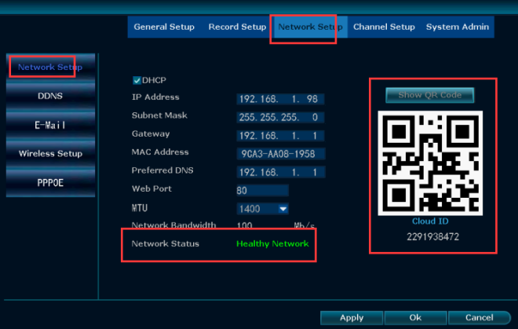
Step1. Login to your Google account on your PC, click “Signing in to Google.” Make sure “2-Step Verification” is off and the “Allow less secure apps” is turned on.
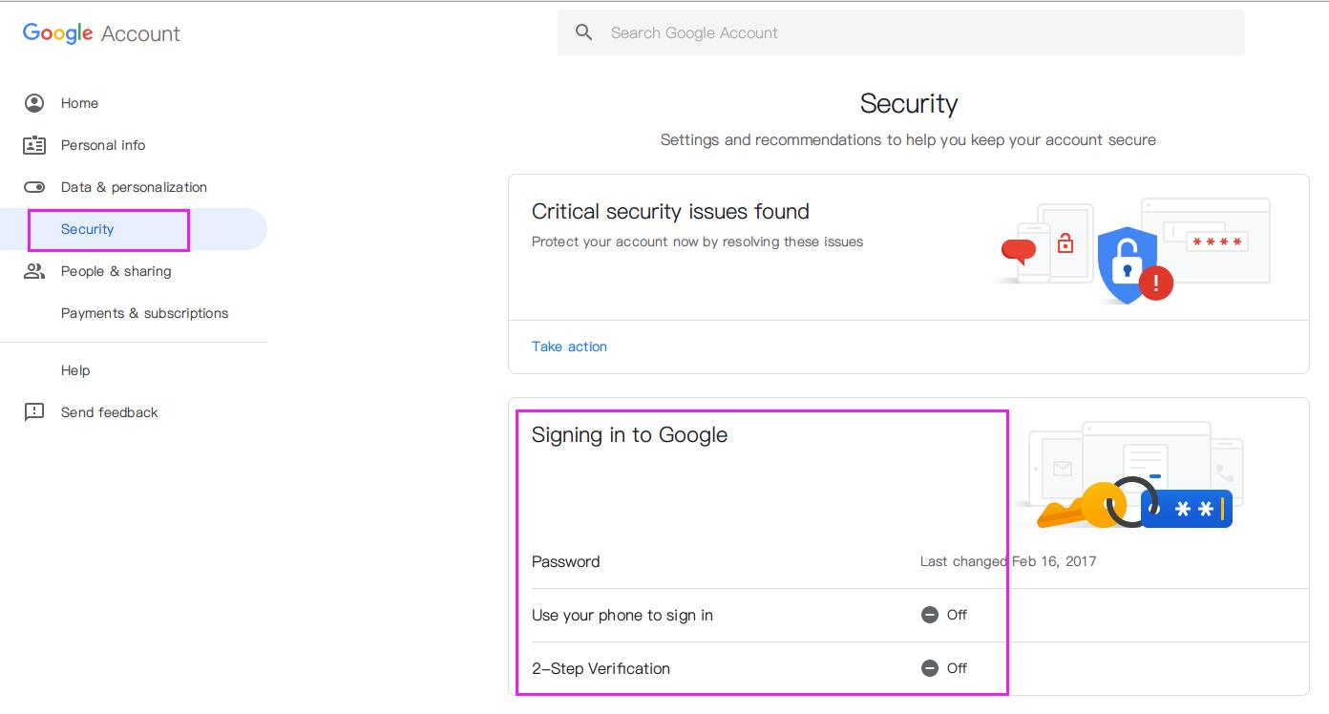
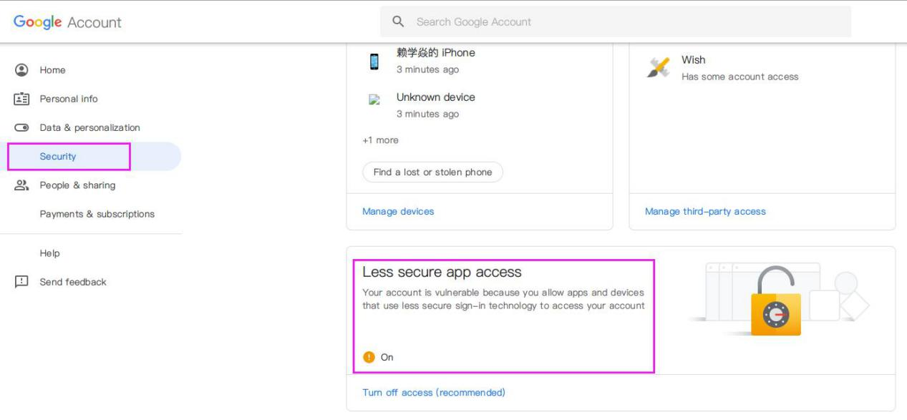
Step2. Go to NVR system, right click: System setup→Channel Setup→Video detection. Check Enable for Motion Detection→Open Alarm-mail Notice
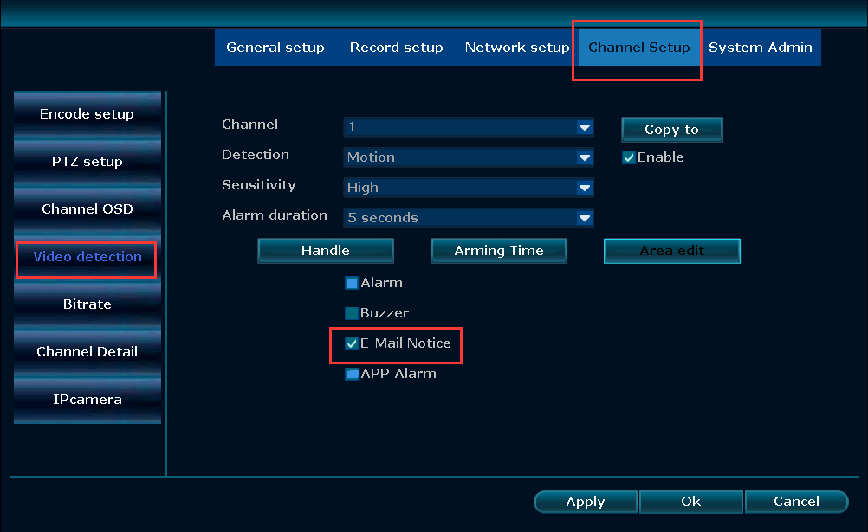
Step3. Setup email account
Click right→System Setting→Network Setting→Email. Enable E-mail function and fill in email settings. Click Test until it is successful. If the test failed, please change to another e-mail and try again. Finally, click OK to save all the settings (No matter test success or not, please click “Apply” to save your settings first).
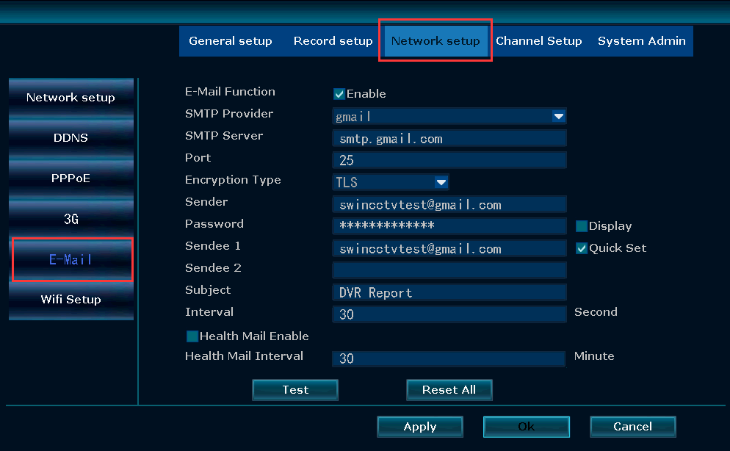
Video instructions:
https://drive.google.com/open?id=1AFaZ2J3F3C1Rj2VsA5ot_4Ru6x1RrL-R
The first setting:
As below picture shown,
Port: 25
Encryption Type: TLS
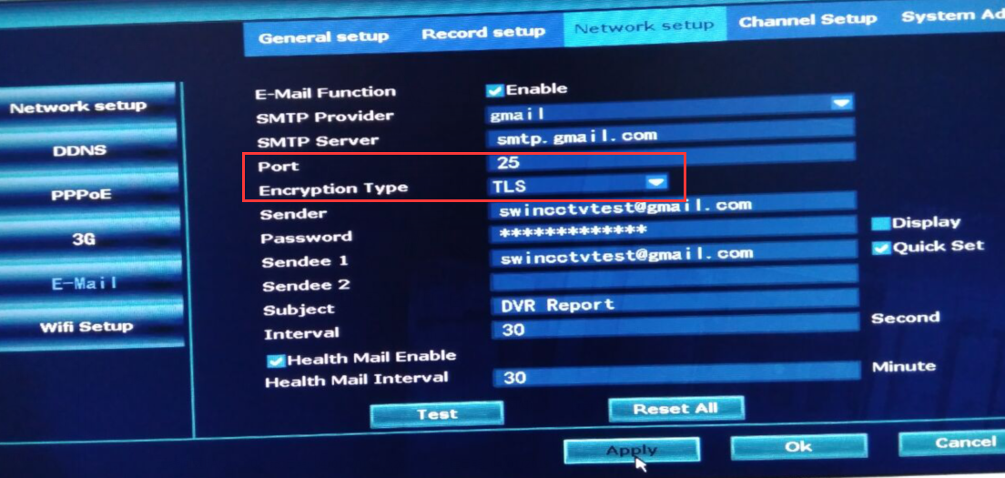
SMTP Server | You email smtp server. For example: smtp.gmail.com
Port | 25
User Name | Sender e-mail address(Gmail e-mail address) to send alarm
Password | Sender E-mail login password
Encryption Type | TLS
Sender | Sender e-mail address to send alarm
Sendee1/Sendee2 | Receiver e-mail address to receive alarm

The second setting :
As below picture shown,
Port: 587
Encryption Type: TLS
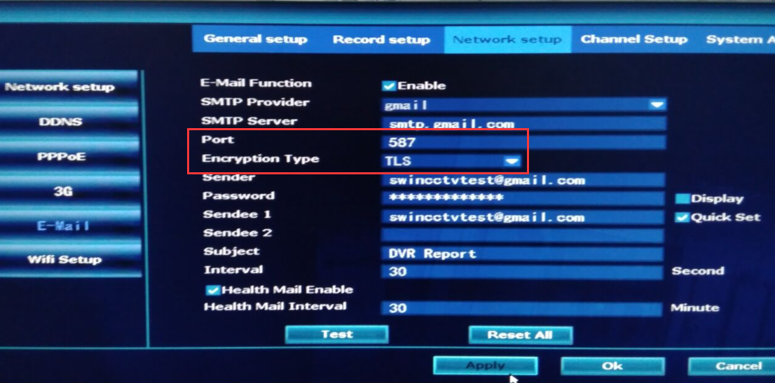
SMTP Server | You email smtp server. For example: smtp.gmail.com
Port | 587
User Name | Sender e-mail address(Gmail e-mail address) to send alarm
Password | Sender E-mail login password
Encryption Type | TLS
Sender | Sender e-mail address to send alarm
Sendee1/Sendee2 | Receiver e-mail address to receive alarm

The third setting :
As below picture shown,
Port: 465
Encryption Type: SSL
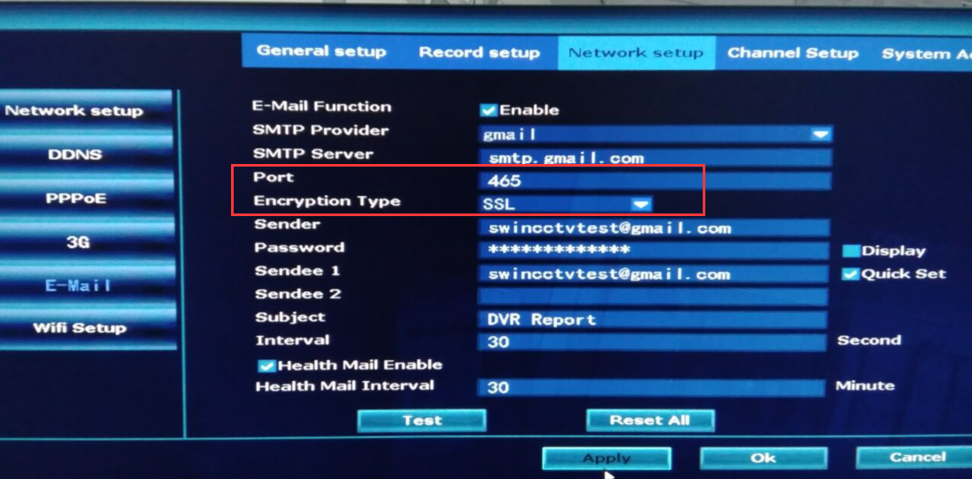
SMTP Server | You email smtp server. For example: smtp.gmail.com
Port | 465
User Name | Sender e-mail address(Gmail e-mail address) to send alarm
Password | Sender E-mail login password
Encryption Type | SSL
Sender | Sender e-mail address to send alarm
Sendee1/Sendee2 | Receiver e-mail address to receive alarm

