- Please download the IP search software of NVR from the link below (only Windows system download is supported)
- Please connect the NVR to the router to make sure your NVR and your computer are on the same LAN (the same router they are connected to)
b. Open "DvrSuite" and search for the IP address of the NVR, as shown below.
https://drive.google.com/open?id=1rTwdxtiy1tCGdQhYr9XECSSl-TUaFGlF
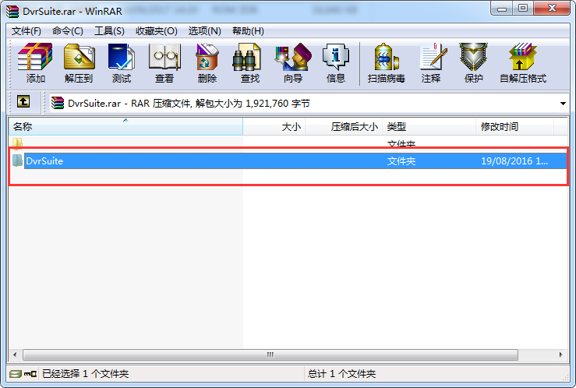
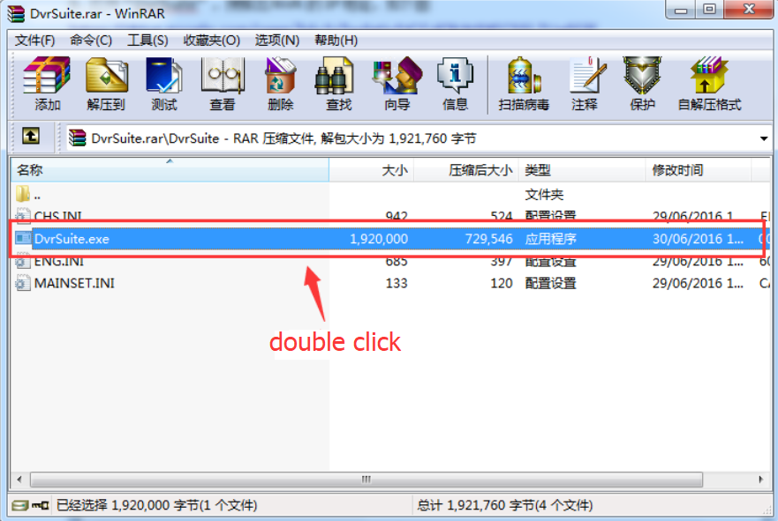
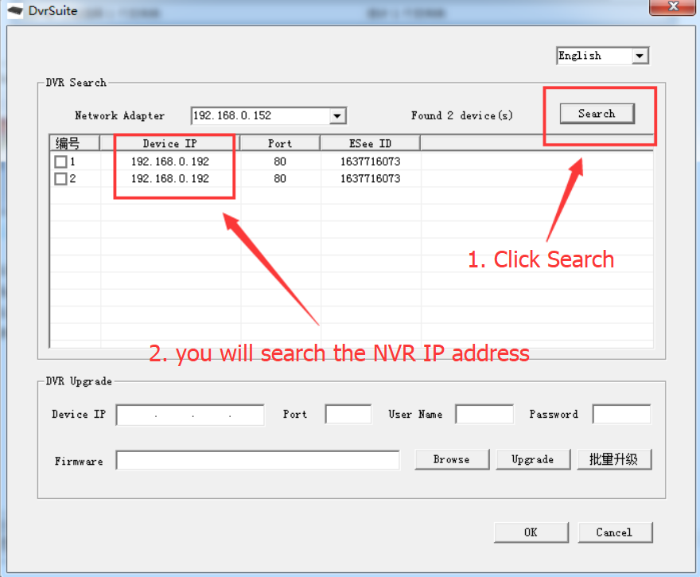
- Open Internet Explorer and log in to the IP address of the NVR that the IP search tool searches for. The username is “admin”. If you do not have a password, you can click Login direct. As shown below (it is recommended to log in with IE browser, other browsers may not be compatible)
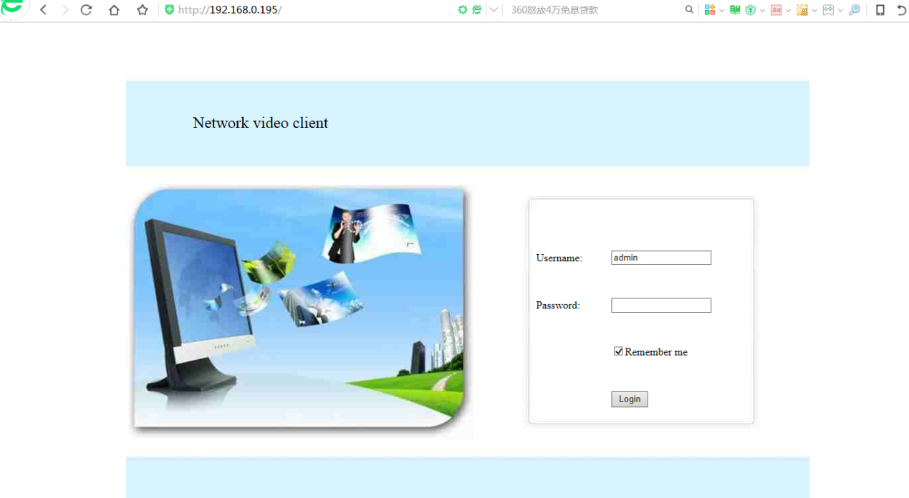
3. Then you can modify the resolution of the camera system, as shown below;
